**Measure 1 Completer Impact and Effectiveness**

NNMC DTE Post-Graduation FOCUS Group Summary

Date: Fall 2023

**Introduction**

The Department of Teacher Education (DTE) at Northern New Mexico College (NNMC) hosted two online focus group sessions, inviting various post-graduation students to provide feedback on their overall program experience as part of the department’s continuous quality improvement initiatives. In particular, DTE sought to discover how well its teacher education programs prepared students for teaching in the classroom.

**Process**

DTE compiled a list of more than 50 graduates ranging from academic year Fall 2020 through Summer 2022. The list reflected graduates from the department’s bachelor programs – BA Elementary, BA Early Childhood Education – and its Alternative Licensure Program certificate in Elementary, Secondary or Special Education.

From that list, a random sample was selected for participation. The final list reflected participants in each of the teacher programs. A total of 38 participants were selected to participate.

Participants were e-mailed a google meeting invitation to their personal and NNMC emails and asked to RSVP. The focus groups were held online on Oct. 4, 2023 (4:30-5:30 p.m.) and Oct. 9 (5:30-6:30 p.m.). Prior to attending the focus group meeting, participants were asked to fill out a demographic questionnaire. Those attending were invited to enter a drawing to win a $25 giftcard and/or NNMC merchandise (water bottle, blanket, notebooks, etc.) Participants were reminded to attend up to three times prior to the two events.

For the Oct. 4, 2023 session, of the 38 participants invited, 2 sent RSVPs and one declined to attend citing a move back to their country of origin. The remaining participants did not respond to the invitation. The 2 participants that sent RSVPs attended the first focus group session. There were no responses to the Oct. 9, 2023, invitation and no one attended the second session.

The first session was hosted by a faculty and staff member. They facilitated conversation with the 2 participants that sent RSVP.

**Demographics**

The participant demographics were as followed:

* Graduation year: Spring 2020 and Spring 2022
* Program: BA ECED and ALP Elementary
* Gender: Female
* Ethnicity: Hispanic
* Currently employed as an educator with a district: First participant, yes; second participant, no
* NMPED license: First participant on route to obtain license, second participant, no

**Results**

Participants were prompted to share insights about their overall experience within their respective teacher education programs. The following is a summary of the topic questions and their responses. A list of questions asked can be found at the end of this document.

**Student teaching**

Participants both agreed that already working at a particular school site that later hosted their student teaching experience was advantageous.

Both participants agreed that having on-site mentors and college supervisors were helpful in learning and implementing best teaching practices.

While the participants did not receive any stipends or incentives, participants agreed that any type of incentive (mentoring/tutoring, stipend, vouchers, resources, etc.) for student teaching would have been beneficial.

**Coursework**

DTE coursework supported their readiness. One participant said that the practice scenarios she participated in her DTE courses helped her understand various aspects of teaching. The other participant said if she had not taken literacy courses, she would have “struggled” to teach basic literacy skills, such as decoding, phonemic awareness, to students.

Participants agreed that DTE coursework prepared them sufficiently to understand how to work with and accommodate diverse learners, including students with disabilities or dual language learners.

One participant gushed about how “excellent” and helpful her professors were.

Because participants were employees at the school sites where they did their student teaching, they were acquainted with curriculum processes and did not have any challenges in writing or implementing curriculum.

**Student learning and assessment**

Both participants indicated that DTE coursework helped them to learn field terminology and processes (e.g.types of assessment, how to assess young children, how to plan learning opportunities based on assessment results). One participant said that because she was taught in DTE coursework literacy frameworks, she was able to identify struggling readers. In turn, she was then able to plan effective instruction and interventions for these students. The second participant said that during student teaching she needed to accommodate a child with autism. Having enrolled in DTE courses that focused on teaching children with disabilities made the second participant more effective in accommodating this student. Both participants said they were better and more effective teachers because of DTE coursework and preparation.

**Challenges**

Participants generally agreed that there were no challenges across their program experience. However, both participants noted that they were at times challenged with delivering online instruction during the COVID pandemic. Both adjusted their practices. One participant was challenged with the amount of paperwork required by her employer.

One participant noted that passing the teaching license certification exams was and continues to be a challenge. The other participant is not currently seeking licensure.

**Opportunities for improvement**

When asked what aspects of DTE’s teacher preparation programs might change or improve, one participant said she had “no complaints” and “everything was done great” and she was “well-prepared.” She also praised the positive support provided by the DTE chair and staff. “I wouldn’t be a teacher if it wasn’t for Sandra Rodriguez.” The other participant praised the quality support she received at DTE throughout her time at NNMC. She said everything was done “wonderfully” and that “everybody” at DTE “is like family,” supportive and “answer all your questions right away.”

**Next steps**

The lack of success in securing Focus Group participants has led to the decision that the DTE must explore alternative measures. Ideas include Case Studies, or using graduate ambassadors during recruiting events.

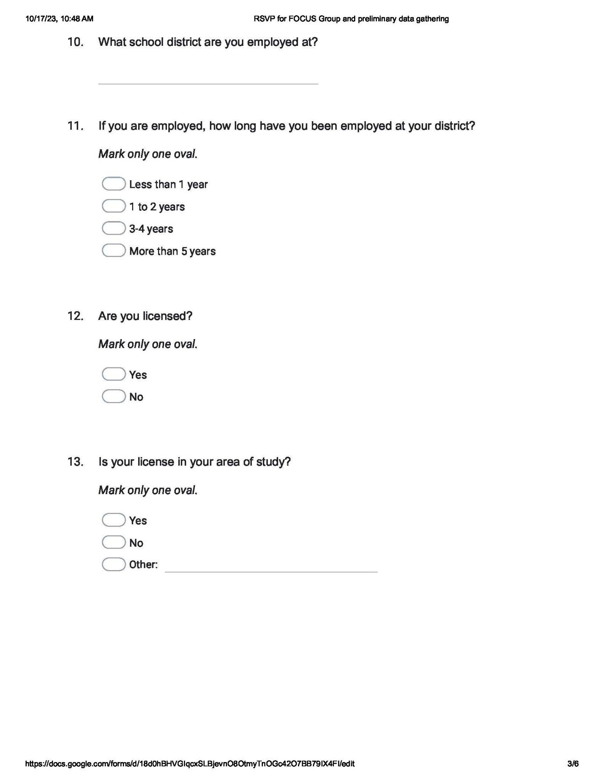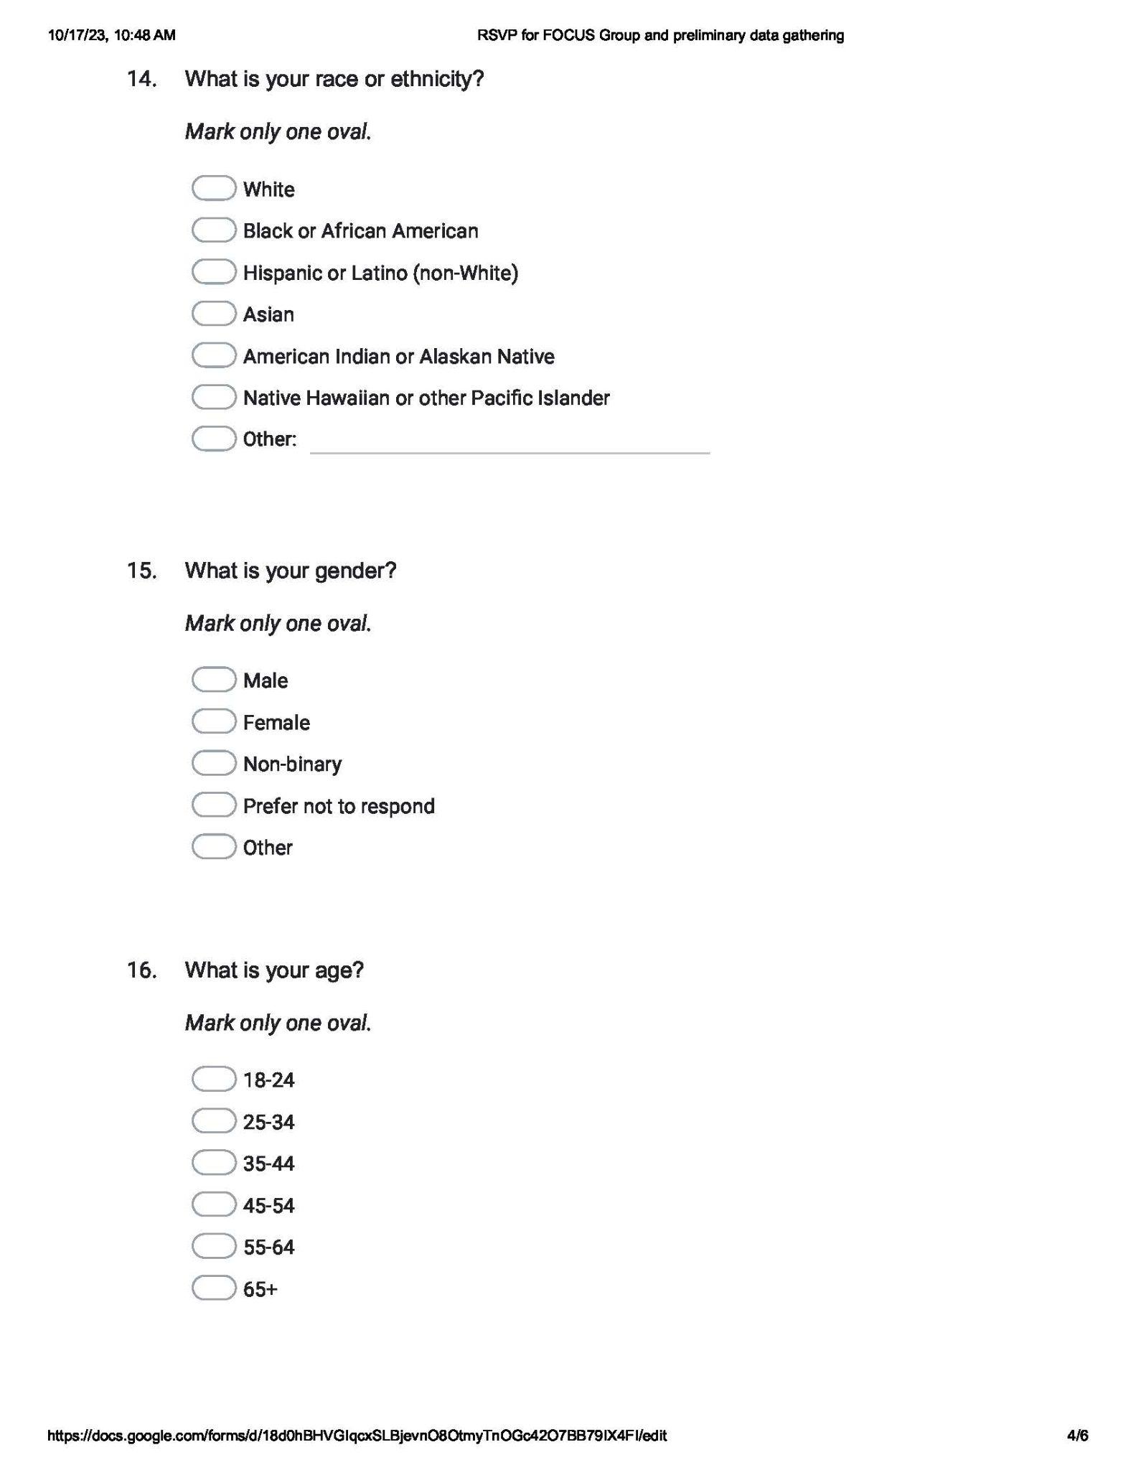

**Demographic survey results**

